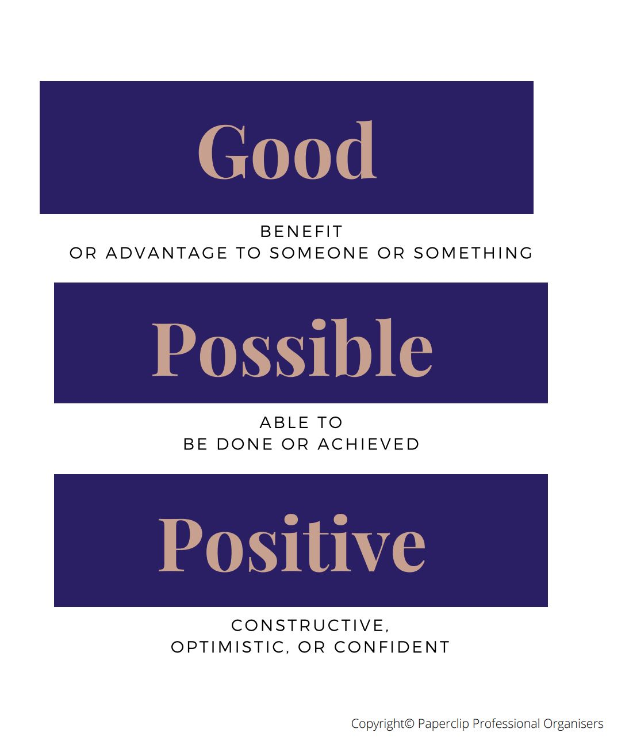
GOOD
POSSIBLE

POSITIVE

Finding the good, the possible and the positive in your current circumstances
Activity: FILL IN THE SECTION BELOW

